HOMEWORK- Week 3-1.1
1) Create Functions to do the following-
- Create a Loop to print if a number is Even or Odd.
- Create a loop to identify If any given number is Prime or Not.
- Create a Loop to print all Prime Numbers between a Number 1 and Number 2.

Titanic Data Set
The sinking of the RMS Titanic is one of the most infamous shipwrecks in history. On April 15, 1912, during her maiden voyage, the Titanic sank after colliding with an iceberg, killing 1502 out of 2224 passengers and crew. This sensational tragedy shocked the international community and led to better safety regulations for ships.
One of the reasons that the shipwreck led to such loss of life was that there were not enough lifeboats for the passengers and crew. Although there was some element of luck involved in surviving the sinking, some groups of people were more likely to survive than others, such as women, children, and the upper-class.
Watch the Video of the Ship sinking here-
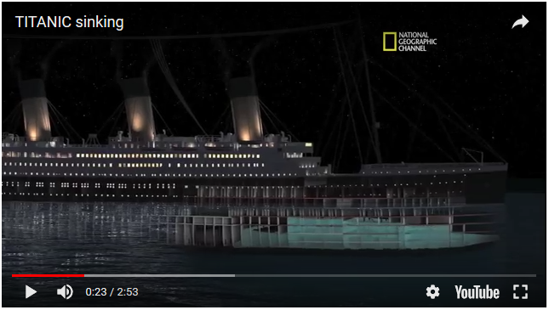
https://www.youtube.com/watch?v=9xoqXVjBEF8

Data Description
- Data Dictionary
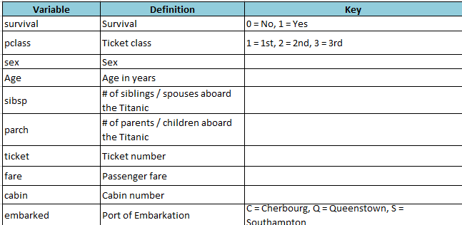
The Dataset is attached in the mail. Please read them into R and do the following-
2) Please read the train.csv file provided in the mail as a data frame and answer the following questions. Use command df=read.csv(“filename.csv”) to read the file. Make sure the Home directory is set to the same folder that contains the csv.
- How many Rows and Columns do you have?
- Check the datatype of each column. Make sure they make sense, if not change the data type of the columns.
- How many Male and Female are present?
- After changing the data types run the summary function and study the output.
- Of the total Passengers, How many survived and how many did not. (hint use table function)
- What proportion Survived?
- How many Male Survived. (hint Table function can take >1 inputs)
- How many Passengers do you have in each Pclass.
- Draw histogram for the Fare paid.
- Find the mean Fare paid by Passengers in each Pclass.
- How many Passengers embarked the Ship and at which Station?
- Count the number of missing values in each column? Does embarked column has any missing value?? Notice carefully.
- Create a smaller dataframe with (all Male and travelling first class) and another df with all female OR anybody below the Age of 20. How many rows are in each df.
- What is the # of Male and Female Survived with respect to each Pclass.
- Use grep to create a subset of all Passenger who survived. Call it df_survived. Whats the number of rows?
- Find all the columns which has the letter ‘e ’ in the column name. How many columns do you get?
- Fill the Missing Values of Age separately for the Male and Female by their Averages.
- Create a new column with the first name of each passenger. Call this column “First name”
- Create a new column with the last name of each passenger. Call this column “last name”
- Create a new column with the Title of each passenger. Call this column “Title” (e.g. Mr, Miss etc)

